ST-E7100 User Manual

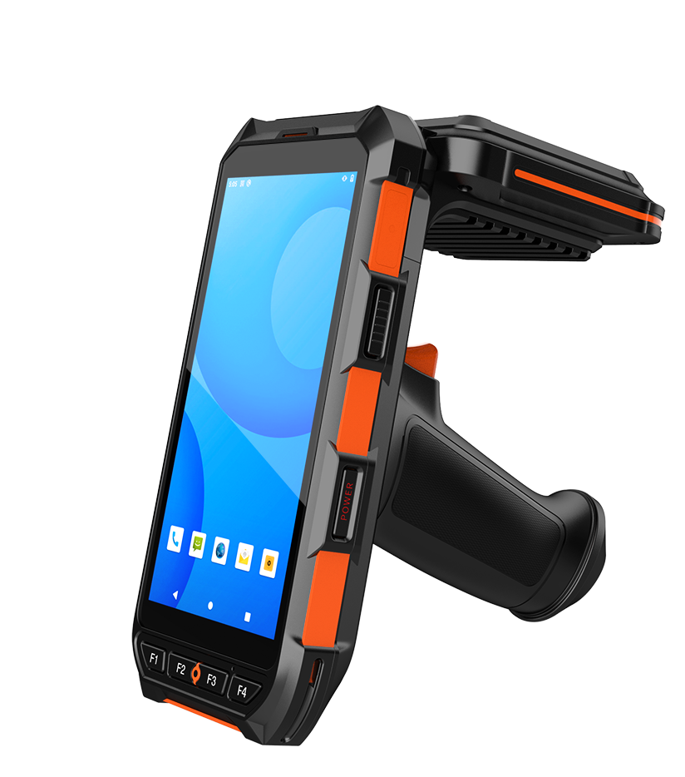

Accessory List
Item | Quantity | Unit
Type-c cable | 1 | pc
Power Adapter | 1 | pc
Battery | 1 | pc

Illustration of equipment
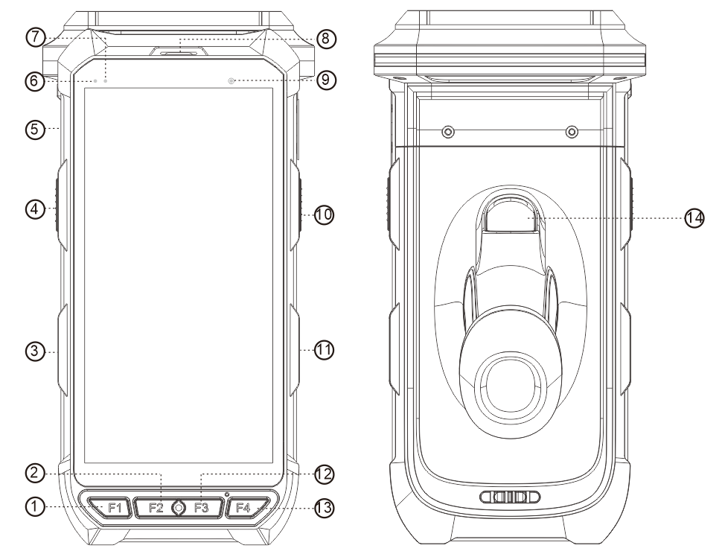

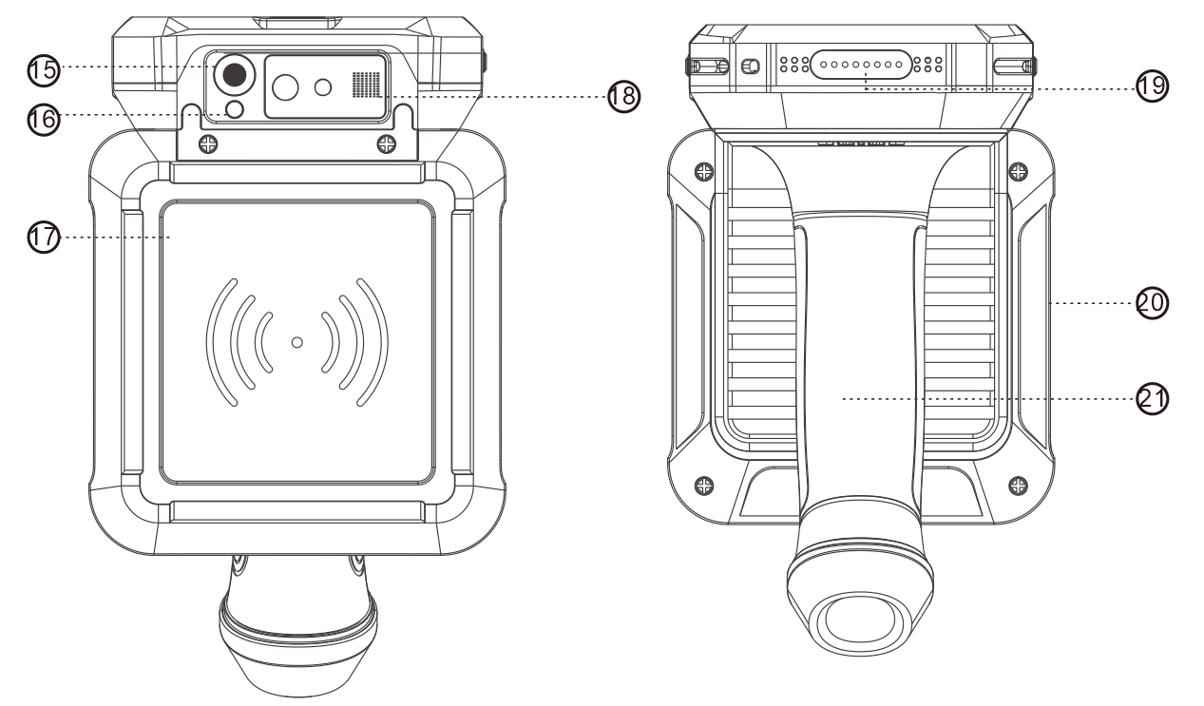
①F1 ②F2 ③Volume ④Reserved Button ⑤USB port ⑥Blue Led Indicator ⑦Red LED indicator ⑧Receiver ⑨Front Camera ⑩Reserved Button ⑪Power Button ⑫F3 ⑬F4 ⑭Pistol Grip Button ⑮Rear Camera ⑯Flashlight ⑰UHF Shield ⑱Barcode Scan Window ⑲Cradle Pogo Pin Connector ⑳UHF Shield Metal Housing ㉑Pistol Grip

Power on/off instructions
Power on: Press and hold the power button in the off state until the device sends out vibration feedback.
Shut down: Press and hold the power button until the shutdown prompt appears in the power-on state, and click Shut down to confirm.
Note: If you do not use the device for a long time, please shut down the device.

Basic operation
Button | Description
Power button | Turn on or turn off or sleeping mode
Menu button | Pop-up options menu
Home button | Back to main interface
Back button | Return to the previous interface
Volume button | Adjust the volume
Custom button | customize functions when developing software

Use and maintenance
- It is not suitable to use the device or charge the device in an environment where the temperature is too high or too low.
- Only use the standard charger or charging dock to charge the battery;
- If you do not use the device temporarily, please store the battery and the device separately. Please do not put
the battery into the device and store it together ,it is better to store them in a cool, dry and ventilated environment.
4.For batteries that are not used temporarily, discharge them once every 3 months, and recharge them to 60%
or 70% of the power for storage.

Product parameter
Product size: 166*79*31±2mm (excluding shield and handle grip)
Screen: 5.5 inch bright screen
System: Android 10.0 OS
Resolution: 720*1440
Battery capacity: 7200mAh
USB type: Type-c data interface
Working hours: 14 hours
Communication: 4G, 3G, 2G free switching
Network: WIFI
Positioning: GPS/Beidou

Optional functions
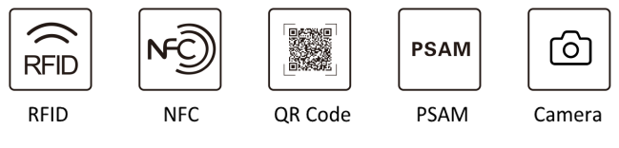

Battery Usage
1. It is forbidden to disassemble the battery cells under any circumstances.
2. It is forbidden to immerse the battery in liquid to prevent moisture.
3. It is forbidden to charge, use or place the battery near heat sources, such as fire, heater, etc., or under high temperature (such as strong sunlight or very hot cars), otherwise it will cause overheating and fire or shorten the life. It is forbidden to directly solder the battery.
4. It is forbidden to heat or throw the battery into a fire, or put the battery in a microwave oven or high-pressure container.
5. If the battery leaks or smells (electrolyte), please discard the battery immediately. If the electrolyte leaks and touches the skin, eyes or other parts of the body, immediately rinse the electrolyte with clean water and seek medical attention.
6. It is forbidden to hit or pierce the battery with sharp parts, such as nails and other sharp objects.
7. It is forbidden to transport or store the battery and metal objects, such as necklaces, hairpins, etc.
8. It is forbidden to hit, step on, or throw the battery with a hammer.
9. The battery is a consumable product, and its capacity will gradually decrease as the use cycle increases. It is recommended that the battery be replaced in time when there is a problem.

Battery Installation and Device Directly Charging Instructions
1. Battery installation:
When installing the battery, please pay attention to the battery installation direction. Put the front of the battery into the battery slot of the device first, and then push the bottom of the battery to enter the device. Do not use brute force to squeeze the battery and the device. The installed battery compartment is flat and firm. .
2. Instructions for using direct charging:
Insert the Type-c data cable into the data port at the bottom of the machine to charge the device. The charging indicator on the device is red when it is charging, and the red light is off when it is fully charged.

Instructions of Charging Cradle
The charging base can charge the device and the spare battery at the same time. When charging the device, insert the device into the host card slot of the charging base directly and hear a slight click sound. When charging the battery separately, lay the battery flat and insert it into the battery card slot of the charging base. Then use the power adapter to power the charging station.
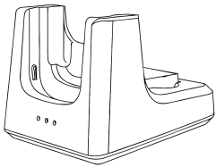

Optional Function Instructions
- QR code
Refer to the built-in demo of the device. If the customer needs secondary development, please contact the technical support engineer; the QR code can scan the barcode of the mainstream symbology, but please pay attention to the clarity of the barcode.
- High frequency (13.56MHz)
Refer to the built-in demo of the device, if you need secondary development, please contact the technical support engineer
3. UHF (860-960MHz)
Refer to the built-in demo of the device. If customers need secondary development, please contact technical support engineers.

Common Failure Analysis
If any problems happens during the use of the equipment, please refer to the following instructions to solve them. If the problem persists, please contact the dealer or manufacturer.
1. Can't charge
a, the equipment charger is not working well
b. The ambient temperature is not suitable
c. Poor contact
2. The device cannot be turned on
a. Please confirm whether the battery has electricity and whether the battery contacts are in good contact.
3. Unable to scan barcode
a. The scanning head cannot emit light and the hardware is damaged;
b. Confirm whether the barcode is a national standard code;
c. Confirm whether the barcode is damaged;
4, high frequency cannot read and write cards
- Please first confirm whether the card type is correct, and then confirm whether the card reading position is correct. Otherwise, please contact technical support to confirm whether the hardware is damaged.
5, UHF cannot read and write cards
- Please confirm whether the card type is correct, and then confirm whether
- the card reading position is correct. Otherwise, please contact technical support to confirm whether the hardware is damaged.
6, some functions cannot be selected
a. If this service is not activated or the local network provider does not support the service, please contact the designated repairer, dealer or network operator

CE Warning
1. Risk of explosion if battery is replaced by an incorrect type. Dispose of used batteries according to the instructions.
2. The product shall only be connected to a USB interface of version USB2.0 or higher.
3. Adapter shall be installed near the equipment and shall be easily accessible.
4. The operating temperature of the device can’t exceed 50℃ and shouldn’t be lower than -20℃.
5. The plug considered as disconnect device of adapter.
6. The device complies with RF specifications when the device used at 5mm from the body and 0mm from the head.
7. The band 5150-5350MHz indoor use only.
Hereby, Shenzhen Handheld-Wireless Co., Ltd. declares that this product is in compliance with essential requirements and other relevant provisions of Directive 2014/53/EU. This product is allowed to be used in all EU member states
FCC Warning
Labeling requirements.
This device complies with part 15 of the FCC Rules. Operation is subject to the following two conditions: (1) This device may not cause harmful interference, and (2) this device must accept any interference received, including interference that may cause undesired operation.
Information to user.
Any Changes or modifications not expressly approved by the party responsible for compliance could void the user's authority to operate the equipment.
Information to the user.
Note: This equipment has been tested and found to comply with the limits for a Class B digital device, pursuant to part 15 of the FCC Rules. These limits are designed to provide reasonable protection against harmful interference in a residential installation. This equipment generates uses and can radiate radio frequency energy and, if not installed and used in accordance with the instructions, may cause harmful interference to radio communications. However, there is no guarantee that interference will not occur in a particular installation. If this equipment does cause harmful interference to radio or television reception, which can be determined by turning the equipment off and on, the user is encouraged to try to correct the interference by one or more of the following measures:
-Reorient or relocate the receiving antenna.
-Increase the separation between the equipment and receiver.
-Connect the equipment into an outlet on a circuit different from that to which the receiver is connected.
-Consult the dealer or an experienced radio/TV technician for help.
Absorption Rate (SAR) information:
This device meets the government's requirements for exposure to radio waves. The guidelines are based on standards that were developed by independent scientific organizations through periodic and thorough evaluation of scientific studies. The standards include a substantial safety margin designed to assure the safety of all persons regardless of age or health.
FCC RF Exposure Information and Statement The SAR limit of USA (FCC) is 1.6 W/kg averaged over one gram of tissue. This device was tested for typical body-worn operations with the back of the device kept 10mm from the body and 0mm from the head. To maintain compliance with FCC RF exposure requirements, use accessories that maintain a appropriate separation distance between the user's body and the back of the device. The use of belt clips, holsters and similar accessories should not contain metallic components in its assembly. The use of accessories that do not satisfy these requirements may not comply with FCC RF exposure requirements, and should be avoided. Use only the supplied or an approved antenna.

